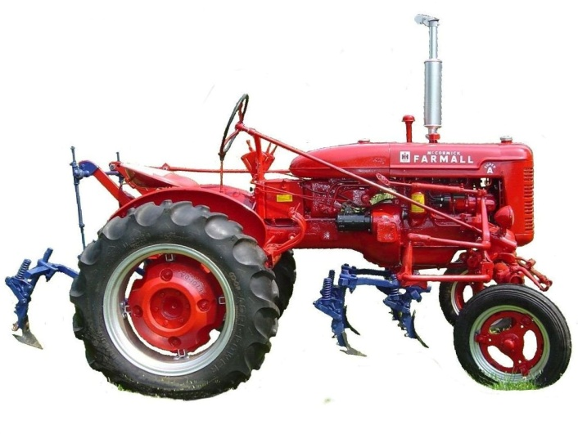

ANTIQUE POWER ASSOCIATION
ESTABLISHED 2003

January 2017

Dear Members,
Good February to all.

--- --- --- from the February meeting --- --- ---

- Struggles and challenges are nothing new to any of us. These bodes of ours age, grow weak, and seem to be susceptible to all kinds of troubles. None of us are immune, but it seems from time to time that some have more than their fair share. We pray for them and we pray for each other, for comfort in afflictions, for peace in tribulations, for strength in weakness, and for wisdom when troubled.

  - Max Lee
  - Reba Reinhardt
  - Horace Isenhour
  - Doug Huffman
  - Jacqueline Hilliard
  - Cole Abernathy
  - Ann Little
  - Kenneth Beach
  - Vee Williams

  - Larry Sigmon
  - Donnie Elmore
  - Vicki Hastings
  - Lorna Sheets
  - Billie Sue Goforth
  - Steve Hefner
  - Wade Hefner
  - Norris Turner
  - Terry Martin
  - Eugene Hartley
  - Ira & Ann Cline
  - Howard Cooper
  - Kelly Blanton
  - Rev. Bobby Langston
  - Don Johnson
  - Carl Porter
  - Jane Abernathy
  - Kay Nash
  - Lilian Setzer

- It is time to ramp up to full speed in preparing for the upcoming show. It will be here before any of us realize so, so the more we get done now, the better off we will be.
  - Emphasis on sponsors and ads is a prime area of focus, particularly tee-shirt sponsors. They need to be nailed down very soon.
  - The Show Committee meets regularly on the 3rd Thursday of every month. Everyone’s help is welcomed and encouraged.

- We need to do revamp the reserved space process. Some have not used their space in the last several years and you will be contacted by Anthony Austin (reserved space coordinator). If you are not going to use it, others are waiting in line.

- Remember, 2017 membership dues are to be paid as of January 1.
  - These monies provide the working capital for our club, everything from stamps and envelopes for newsletters, to initial printing of both tee-shirts and programs.
  - Being up-to-date on membership dues is also a prerequisite to the use of a reserved spot during the show.
  - Tim Hollar and Butch McIntyre are still overseeing the collection of dues. You can pay them at the monthly meetings, at Hollar Tractor, or Sig’s Tire, or you can send your $20 check to the club’s mailing address (below).

--- --- --- UP-COMING EVENTS --- --- ---

Feb 16 Sig’s Show Committee meeting
Feb 22-25 Ft. Meade, FL Florida Flywheelers Show
Mar 2 Sig’s monthly meeting
Mar 16 Sig’s Show Committee meeting

☺ ☺ !!!!! HAPPY BIRTHDAY !!!!! ☺ ☺

February birthdays

2 – Ann Cline
5 – Carolyn Matthews
11 – Allen Lindsay
13 – Doug Hefner
17 – Wade Hefner
17 – Jon Lail
18 – Jim Yount
21 – Reggie Sloan
23 – Calvin Schronce
23 – Kelly Matthews
24 – Dee Stewart
28 – Don Greenlee

March birthdays

3 – Kenneth Cannon
8 – Keith Little

11 – Gary Detter
12 – Rahn Painter
19 – Jason Icard
20 – James Couch
23 – Buddy Huffman

-- --- --- THE CLASSIFIEDS --- --- ---

Is there anything you would like to sell or are you looking for something special? List it here.
(Item listings will run for 3 months before expiring. Let us know when an item is sold or bought.)

WANTED

Allis-Chalmers B engine,
Troy Elmore (16-10)

FOR SALE

Allis-Chalmers G taillight, NOS,
Butch Fox (828) 4566-3940 (17-01)

Bolens Ride Master, all original, $700;
Butch Fox (828) 4566-3940 (17-01)

Wards walk-behind tractor 3-spd, all original,
Butch Fox (828) 4566-3940 (17-01)

-- --- --- A thought for the month --- --- ---

By this time of year, many people have made resolutions to do something differently, but have failed to carry through with them. Why? Either what they resolved to do was not worth doing, or they never really intended in their heart to do it.
Many things are worth doing, but is that because of convenience or profit, or because they are the good and right things to do? If they are good and right, do we stop doing them when they become inconvenient or a liability?
We are faced with opportunities to do the good and the right, not only once at the beginning of each year, but at every waking moment of every day. But do we opt for that which only appears to be good – do we choose to follow that which everyone around us thinks is proper and right. The great majority of men and women will choose convenience, appearance, or social acceptance over that which is truly good and right. Are we (you and I) are to be counted in their number?
Let us not be ignorant of what is truly good and right and proper, and let us not be blind to the influence of convenience, profit, or peers.
May this year be one in which each of us endeavors to learn what is truly good and right and then striving with all our heart and strength make it an active part of our lives even if we find it to be inconvenient, unprofitable, or difficult.
May God give us the wisdom and strength we need to do so.

God bless you all.
See you in March Your Secretary, David Setzer

President: Kevin Black 828-464-1950 Vice Pres: Wilson Sigmon 828-256-2176
Treasurer: Kermit Nash 828-459-9616 Secretary: David Setzer 828-850-4943
Show Chair: Teddy Hefner 828-310-5525 Asst. Show Chair: Anthony Austin
Asst. Secretary: Kevin Sigmon 828-256-21

Board of Directors:
Phillip Spencer, Howard Reinhardt, Ned Story, Teddy Hefner, Tim Hollar, Butch McIntyre

Foothills Antique Power Association
5851 St. Peter’s Church Road, Conover, NC 28613
Foothillsantique.com

